

# 

[**DataBase Administration Management System**](https://classroom.google.com/c/NDI2ODkzODkzMTY5)

**Project**

**Online Shopping Store**

**Submitted to: Dr. Mazhar Bukhari**

**Members: 1.Muhammad Shoaib Kalim (bsf2100926)**

**2. Muhammad Umar Khan (bsf2101082)**

***University of Education, Lahore Division of Science and Technology, Township Campus Lahore***

**ONLINE SHOPPING STORE**

An online shopping system is a process in which people (specifically customers) are being provided with the option of purchasing goods and services directly from the seller, all in a real-time environment. Online shopping is an application of the internet as electronic commerce. From the business perspective, customers usually find the products more attractive, on websites, as they get all the details available there. There are millions of online users available in our country also.

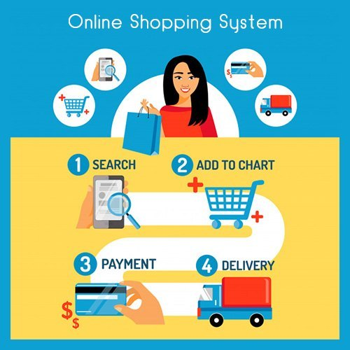

**Description Of Online Shopping System:**

People in large number are doing online shopping today, and it is not only because it is convenient as one can shop from home, but also because there is an ample number of varieties available, with a high competition of prices, and also it is easy to navigate for searching regarding any particular item.

In other words, the project aimed at creating a virtual shop environment for users, in some handy form, which will be available to them through the internet. Although the idea of developing online shopping websites is not new in the electronic market and has been evolved soon after the World Wide Web(www).

In the present scenario, the biggest market for this (online shopping) business is by highly educated people, mostly. This system has been designed keeping in mind all the aspects such as loading the data, complexity, and maintaining the security of user credentials. Here in this system, complexity refers to the total number of features being provided to users, and their smooth arrangement and functioning required.

A typical online store enables the customer to browse the firm's range of products and services, view photos or images of the products, along with information about the product specifications, features and prices. Online stores usually enable shoppers to use "search" features to find specific models, brands or items.

**EXPLAINATION:**

For an online shopping system, several key entities play vital roles in representing different aspects of the system.

**Here are some essential entities:**

**1. Customer:**

- Represents individuals who browse and make purchases on the online store.

- Attributes:

* CustomerID (Primary Key),
* Name,
* Email,
* Address,
* Phone

**2. Product:**

- Attributes:

* ProductID (Primary Key),
* Name,
* Description,
* Price,
* StockQuantity

- Represents the products available for purchase.

**3. Order:**

- Represents a customer's purchase transaction.

- Attributes:

* OrderID (Primary Key),
* CustomerID (Foreign Key),
* OrderDate,
* TotalAmount,
* Status

**4. OrderItem:**

- Represents individual items within an order, linking products to specific orders.

- Attributes:

* OrderItemID (Primary Key),
* OrderID (Foreign Key),
* ProductID (Foreign Key),
* Quantity,
* Subtotal

**5. Payment:**

- Represents the payment details associated with an order.

- Attributes:

* PaymentID (Primary Key),
* OrderID (Foreign Key),
* Amount,
* PaymentDate,
* PaymentMethod

**6. Category:**

- Represents product categories for better organization.

- Attributes:

* CategoryID (Primary Key),
* Name,
* Description

**7. Cart:**

- Represents the shopping cart, where customers can temporarily store selected items before making a purchase.

- Attributes:

* CartID (Primary Key),
* CustomerID (Foreign Key),
* Status

**8. Review:**

- Represents customer reviews for products.

- Attributes:

* ReviewID (Primary Key),
* ProductID (Foreign Key),
* CustomerID (Foreign Key),
* Rating,
* Comment

**9. Address:**

- Represents customer addresses for shipping purposes.

- Attributes:

* AddressID (Primary Key),
* CustomerID (Foreign Key),
* Street,
* City,
* State,
* ZipCode

**10. Admin/User:**

- Represents administrators or users who manage the online shopping system.

- Attributes:

* UserID (Primary Key),
* Username,
* Password,
* Role

These entities cover various aspects of an online shopping system, from customers and products to orders, payments, and administrative functionalities. Depending on the specific requirements of your system, you may need to customize or expand this list.

**\*\*\*\*\*\*\*\*\*\*\*\*\*\*\*\*\*\*\*\*\*\***

# Entity Relationship Diagram

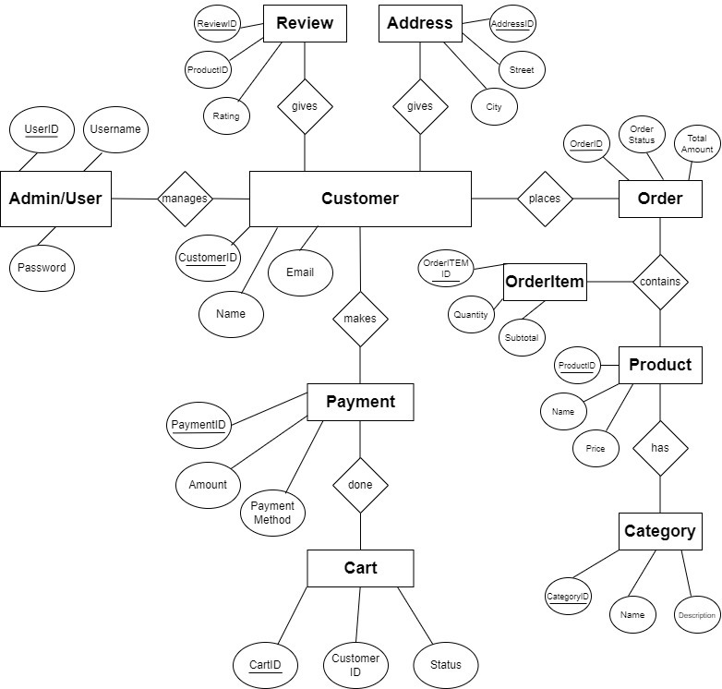

**Applying queries for the database (DDL):**

CREATE TABLE **Customer** (

CustomerID INT PRIMARY KEY,

Name VARCHAR(255),

Email VARCHAR(255),

Address VARCHAR(255),

Phone VARCHAR(20)

);

CREATE TABLE **Product** (

ProductID INT PRIMARY KEY,

Name VARCHAR(255),

Description VARCHAR(255),

Price INT,

StockQty INT

);

CREATE TABLE **Orderr** (

OrderID INT PRIMARY KEY,

CustomerID INT REFERENCES Customer(CustomerID),

OrderDate DATE,

TotalAmount INT,

Status VARCHAR(50)

);

CREATE TABLE **OrderItem** (

OrderItemID INT PRIMARY KEY,

OrderID INT REFERENCES Orderr (OrderID),

ProductID INT REFERENCES Product(ProductID),

Quantity INT,

Subtotal INT );

CREATE TABLE **Payment** (

PaymentID INT PRIMARY KEY,

OrderID INT REFERENCES Orderr(OrderID),

Amount INT,

PaymentDate DATE,

PaymentMethod VARCHAR(50)

);

CREATE TABLE **Category** (

CategoryID INT PRIMARY KEY,

Name VARCHAR(100),

Description VARCHAR(100)

);

CREATE TABLE **Cart** (

CartID INT PRIMARY KEY,

CustomerID INT REFERENCES Customer(CustomerID),

Status VARCHAR(50)

);

CREATE TABLE **Review** (

ReviewID INT PRIMARY KEY,

ProductID INT REFERENCES Product(ProductID),

CustomerID INT REFERENCES Customer(CustomerID),

Rating INT,

Comment VARCHAR(100)

);

CREATE TABLE **Address** (

ADDRESSID INT PRIMARY KEY,

CustomerID INT REFERENCES Customer(CustomerID),

Street VARCHAR(255),

City VARCHAR(100),

State VARCHAR(100),

ZipCode VARCHAR(20)

);

CREATE TABLE **AdminUser** (

userID INT PRIMARY KEY,

Username VARCHAR(50),

Password VARCHAR(255),

Role VARCHAR(50)

);

# Applying constraints on queries (DML):

INSERT INTO **Customer**

(CustomerID, Name, Email, Address, Phone)

**VALUES**

(1, 'John Doe', 'john@example.com', '123 Main St', '555-1234'),

(2, 'Jane Smith', 'jane@example.com', '456 Oak St', '555-5678'),

(3, 'Bob Johnson', 'bob@example.com', '789 Pine St', '555-9876'),

(4, 'Alice Brown', 'alice@example.com', '101 Maple St', '555-4321');

INSERT INTO **Product**

(ProductID, Name, Description, Price, StockQty)

**VALUES**

(101, 'Laptop', 'Powerful laptop for work and play', 999, 50),

(102, 'Smartphone', 'High-performance smartphone', 499, 100),

(103, 'Headphones', 'Premium noise-canceling headphones', 149, 30),

(104, 'Camera', 'Professional-grade digital camera', 799, 20);

INSERT INTO **Orderr**

(OrderID, CustomerID, OrderDate, TotalAmount, Status)

**VALUES**

(1001, 1, '2023-01-15', 1499, 'Delivery'),

(1002, 2, '2023-02-20', 4999, 'Pending'),

(1003, 3, '2023-01-15', 1399, 'Delivery'),

(1004, 4, '2023-02-20', 199, 'Delivery');

INSERT INTO **OrderItem**

(OrderItemID, OrderID, ProductID, Quantity, Subtotal)

**VALUES**

(5001, 1001, 101, 2, 1999),

(5002, 1002, 102, 1, 499),

(5003, 1003, 103, 3, 449),

(5004, 1004, 104, 1, 799);

INSERT INTO **Payment**

(PaymentID, OrderID, Amount, PaymentDate, PaymentMethod)

**VALUES**

(2001, 1001, 1499, '2023-01-15', 'Credit Card'),

(2002, 1002, 499, '2023-02-20', 'PayPal'),

(2003, 1003, 1399, '2023-01-15', 'Credit Card'),

(2004, 1004, 199, '2023-02-20', 'Credit Card');

INSERT INTO **Category**

(CategoryID, Name, Description)

**VALUES**

(301, 'Electronics', 'Electronic devices and accessories'),

(302, 'Clothing', 'Fashionable apparel for all occasions'),

(303, 'Audio', 'Audio products and accessories'),

(304, 'Cameras', 'Photography equipment');

INSERT INTO **Cart**

(CartID, CustomerID, Status)

**VALUES**

(4001, 1, 'Active'),

(4002, 2, 'Inactive'),

(4003, 3, 'Active'),

(4004, 4, 'Inactive');

INSERT INTO **Review**

(ReviewID, ProductID, CustomerID, Rating, Comment)

**VALUES**

(6001, 101, 1, 5, 'Great laptop!'),

(6002, 102, 2, 4, 'Good smartphone, but battery life could be better'),

(6003, 103, 3, 5, 'Excellent sound quality'),

(6004, 104, 4, 4, 'High-quality camera for photography enthusiasts');

INSERT INTO **Address**

(AddressID, CustomerID, Street, City, State, ZipCode)

**VALUES**

(7001, 1, '123 Main St', 'Anytown', 'CA', '12345'),

(7002, 2, '456 Oak St', 'Sometown', 'NY', '67890'),

(7003, 3, '789 Pine St', 'City Ville', 'TX', '54321'),

(7004, 4, '101 Maple St', 'Village town', 'FL', '98765');

INSERT INTO **AdminUser**

(UserID, Username, Password, Role)

**VALUES**

(8001, 'admin', 'adminpassword', 'Admin'),

(8002, 'manager', 'managerpassword', 'Manager');

**\*\*\*\*\*\*\*\*\*\*\*\*\*\*\*\*\*\*\*\*\*\*\*\*\*\***

**Customer**

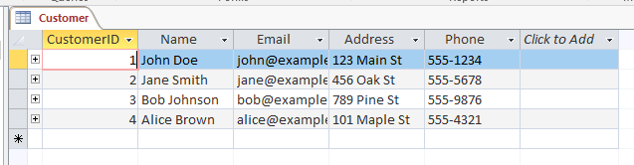

**Product**

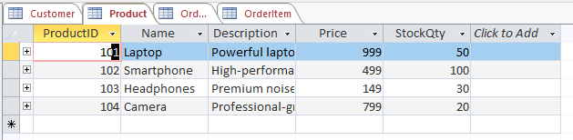

**Orderr**

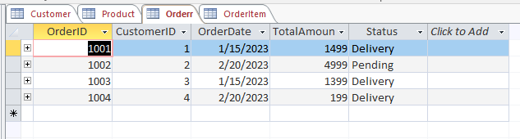

**OrderItem**

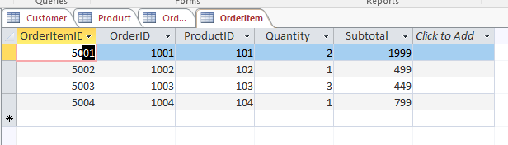

**Payment**

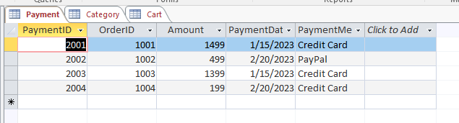

**Category**

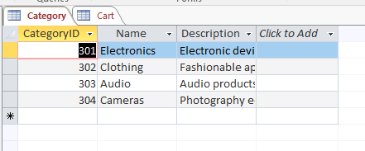

**Cart**

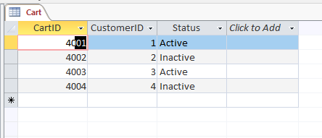

**Review**

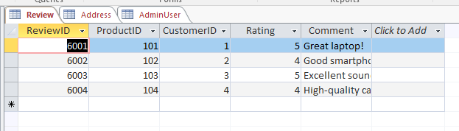

**Address**

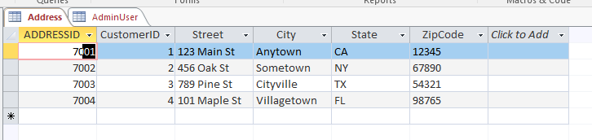

**AdminUser**

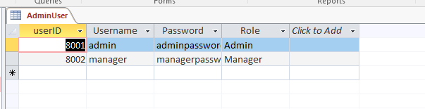

**\*\*\*\*\*\*\*\*\*\*\*\*\*\*\*\*\*\*\*\*\*\*\*\***

**Selection:**

SELECT *

FROM **Customer**

WHERE CustomerID IN (

SELECT CustomerID

FROM Orderr

WHERE TotalAmount > 1000

);

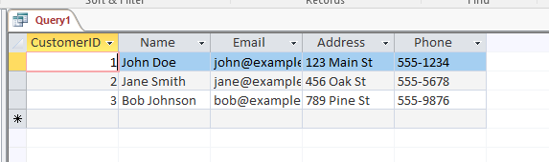

SELECT *

FROM **Product**

WHERE StockQty < 50;

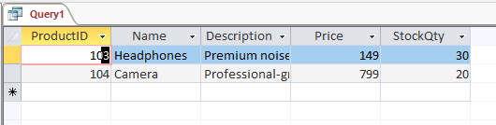

SELECT *

FROM **Orderr**

WHERE Status = 'Pending';

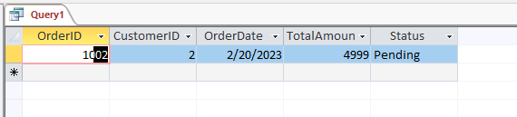

**\*\*\*\*\*\*\*\*\*\*\*\*\*\*\*\*\*\*\*\*\***

**Projection:**

SELECT Name, Email

FROM **Customer**;

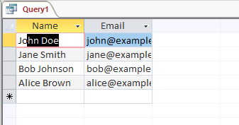

SELECT Name, Price

FROM **Product**;

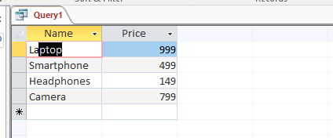

SELECT OrderID, OrderDate, TotalAmount

FROM **Orderr**

WHERE Status = 'Completed';

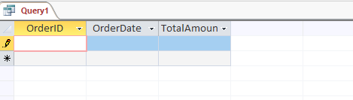

**\*\*\*\*\*\*\*\*\*\*\*\*\*\*\*\*\*\***

**Relationships**



